HPA vs. VPA: Using Kubernetes Autoscaling to Improve Efficiency

Autoscaling is key to maximizing the efficiency of your Kubernetes cluster's resource usage and performance. Horizontal Pod Autoscaler (HPA) and Vertical Pod Autoscaler (VPA) are the two main choices provided by Kubernetes. We will go into the details of these two strategies in this article and see how nKS by nOps advances Kubernetes optimization.

# Horizontal Pod Autoscaler (HPA)

## Technical Foundation

HPA is a well-known feature in the Kubernetes toolkit. Its primary function is to adjust the number of pods in a deployment based on observed CPU or memory utilization. HPA ensures that your application scales horizontally to meet the demand, making it a crucial tool for maintaining performance during traffic spikes.

## Scalability

HPA excels at handling fluctuating workloads. It allows you to specify resource utilization thresholds, and when those thresholds are exceeded, HPA dynamically adds or removes pods to maintain the desired resource utilization level. This results in optimal resource usage and improved application performance.

# Vertical Pod Autoscaler (VPA)

## Vertical Scaling Precision

On the other side of the scaling spectrum, we have VPA. It takes a different approach by optimizing the resource allocation of individual pods rather than adding or removing them. It focuses on maximizing resource utilization within each pod, which can be especially beneficial for applications with specific resource requirements.

## Resource Efficiency

VPA fine-tunes your pods by adjusting CPU and memory resource requests based on historical usage patterns. This prevents over- or under-provisioning of resources, leading to cost savings and more efficient resource utilization. VPA is particularly useful when dealing with applications that have varying resource demands throughout their lifecycle.

# Why nKS by nOps?

Both HPA and VPA bring significant benefits to Kubernetes environments, but they have limitations. HPA's horizontal scaling might lead to overprovisioning at times, while VPA's fine-grained vertical scaling may not address all workload scenarios. This is where nKS by nOps comes into play.

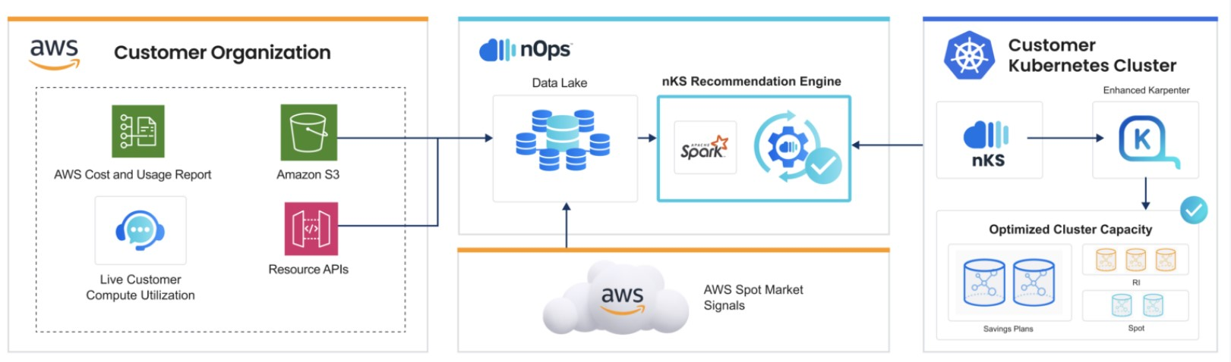

Figure

# nKS: The Evolution of Kubernetes Autoscaling

nKS is a game-changer in the world of Kubernetes optimization. It seamlessly integrates with HPA and VPA, taking their capabilities to new heights. Here's why nKS deserves your attention:

Real-Time Data Ingestion: nKS collects data from various sources, including the spot market, existing commitment plans, and resource utilization. This real-time data provides nKS with a comprehensive view of your cluster's performance and cost structure.

Machine Learning-Driven Optimization: Using this data, nKS leverages machine learning models to determine the most cost-effective compute utilization for resources at any given time. It considers your existing reservations, savings plans, spot market signals, and historical usage patterns to make informed decisions.

Dynamic Workload Adjustment: nKS adapts and dynamically adjusts your workload to ever-changing spot market conditions. It prioritizes cost-effectiveness while ensuring your application's performance requirements are met.

Tailored Solutions: nKS is not a one-size-fits-all solution. It tailors its optimization strategies to your specific environments and workloads. Whether you rely on horizontal scaling, vertical scaling, or a combination of both, nKS optimizes your cluster accordingly.

Advanced Termination Protection: nKS can detect potential node terminations an hour before they happen, providing you with the confidence to run your workloads even on spot instances without the fear of interruptions.

Real-Time Pricing Reconsideration: Continuously analysing spot market pricing, nKS ensures you are always using the most cost-efficient instance types. It considers your existing commitments, preventing potential cost pitfalls.

# Conclusion

nKS by nOps bridges the gap between HPA and VPA, offering the best of both worlds. It combines the agility of horizontal scaling with the precision of vertical scaling while optimizing costs in real-time. With nKS, your Kubernetes cluster becomes a dynamic, cost-efficient powerhouse that effortlessly adapts to your workload's needs.

In the ever-evolving landscape of Kubernetes optimization, nKS is the compass that guides you toward peak efficiency and cost-effectiveness. It's the tool you need to navigate the complexities of autoscaling in a dynamic cloud environment.

So, if you are serious about maximizing your Kubernetes cluster's potential, it's time to explore what nKS by nOps can do for you. Take the leap into the future of Kubernetes optimization and elevate your container orchestration to new heights.